- Any new TMP set to stage 5 in sales force should appear on this report in salesforce, this report will serve as a guideline through onboarding:
https://spafinder.my.salesforce.com/00O600000041PtO
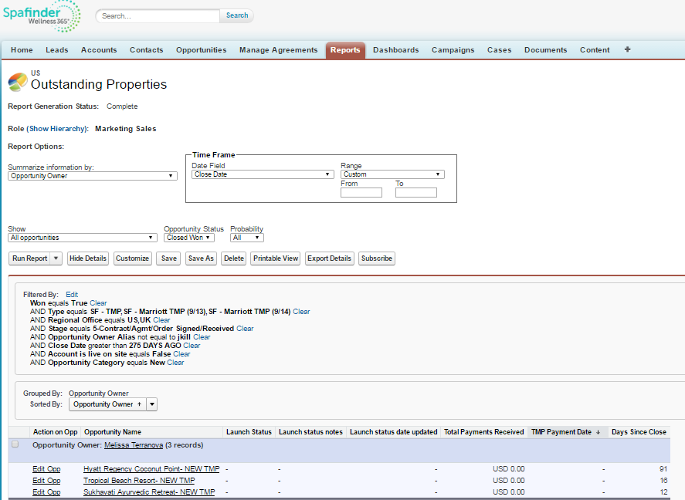

- In order for billing to invoice create account ID in Admin to generate business ID. Add Business Id to salesforce, and notify accounting for billing.

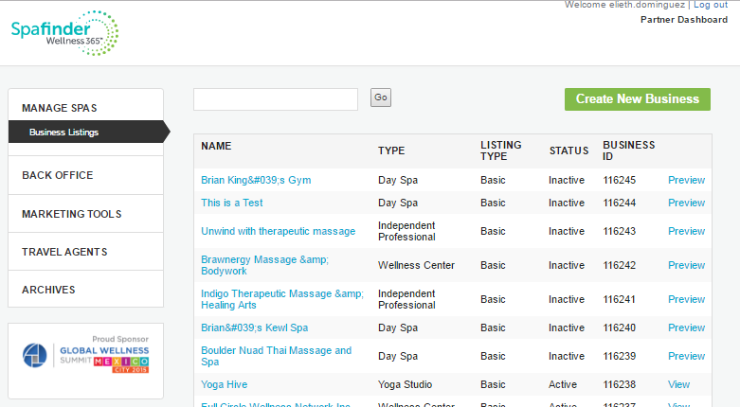
- Enter Contact + Partner information:

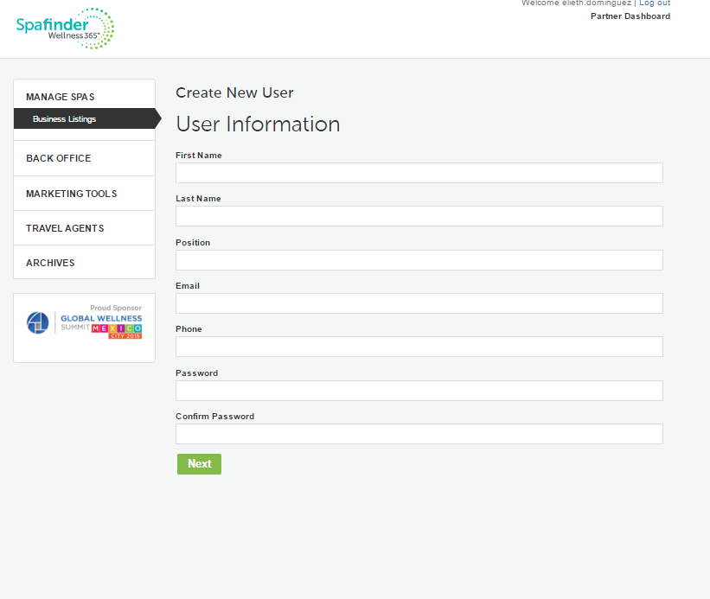
- Send welcome email to partner that includes;
  - Questionnaire and list of assets needed (Social media handles, business information, 16 thumbnail images, 1 hero image, Video, Menu, Special offer, services, Tout (property Slogan.)
  - ACH form ( and International wire transfer request depending on property location)
- Once questionnaire is received begin creating the profile in Admin: https://www.spafinder.com/admin/business/businesslist.htm?filter=
  - Create the profile (Add social media handles, business information, 16 thumbnail images, 1 hero image, Video, Menu, Special offer, services, Tout (property Slogan.) Editorial will provide the Content for Business description, services, dining & amenities.

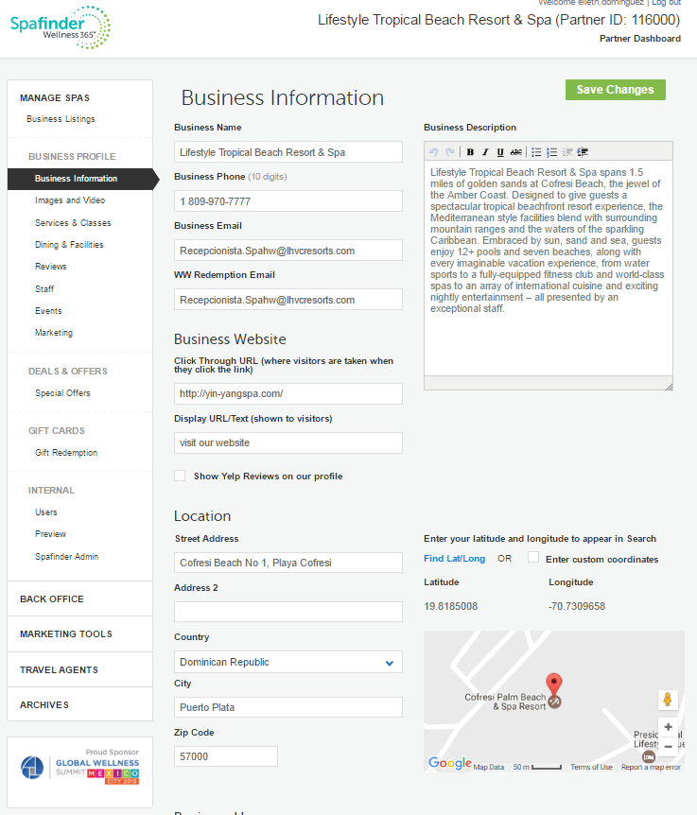
- Add images
  - Rotating images (16 images need to be resized and enhanced in Photoshop to 600x500pxl and uploaded to the listing
  - Add Hero Image size:1200x270pxl
  - Enter URL to online promotional video of the property

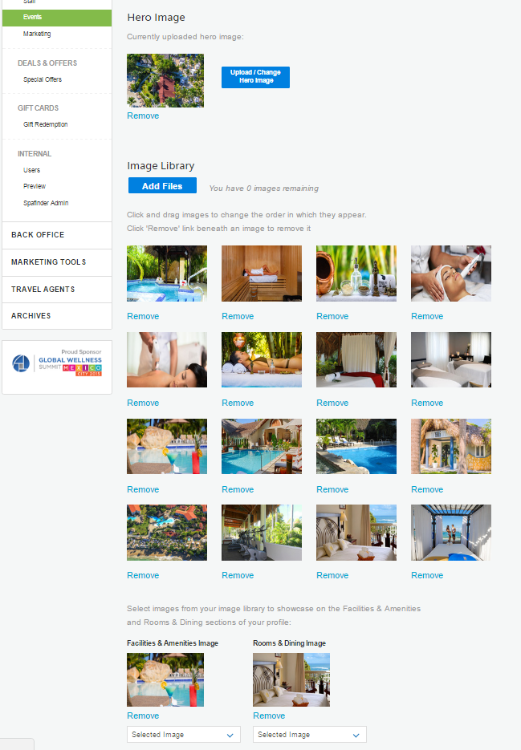
- Add spa menu (PDF) and mark all services that apply.
Many times I have properties that provide multiple menus and they wish to upload all to the listing however only one can be uploaded. If the property provides the link to the different menus on their website I add the hyperlink in the Services description. By doing this it redirects viewers away from property listing directly to their website.

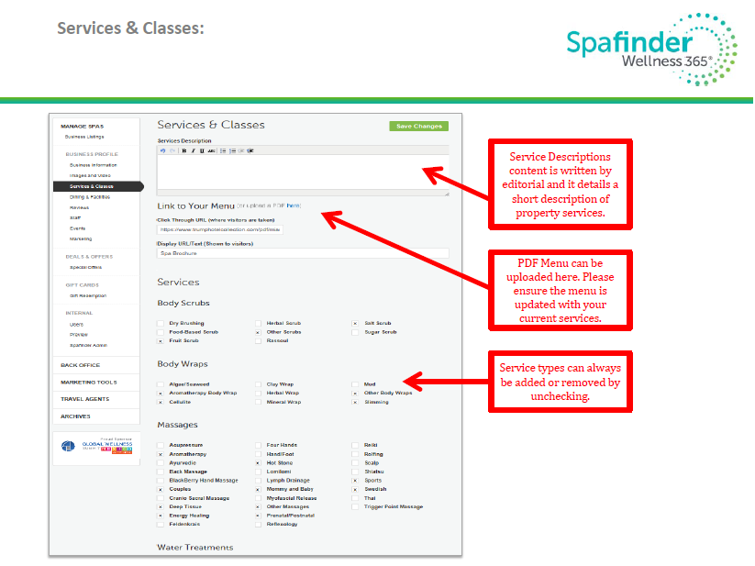
- Add special offers – detail what’s included, price, how to Book, Good to know, links, and validation dates
  - Seasonal Offers, Holiday Offers, Day Spa Offer, Group Packages
  - 4 offers are visible, partner can have up to 6.

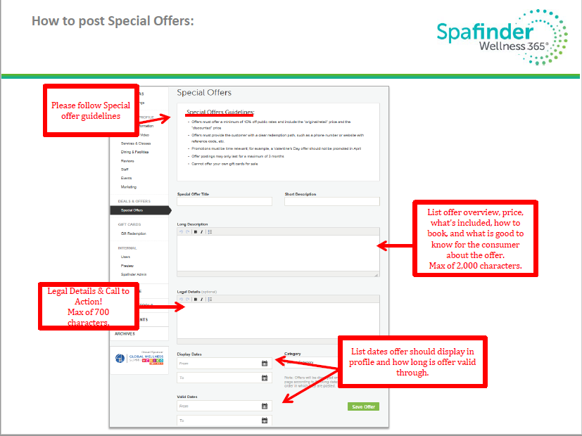
Save & preview:
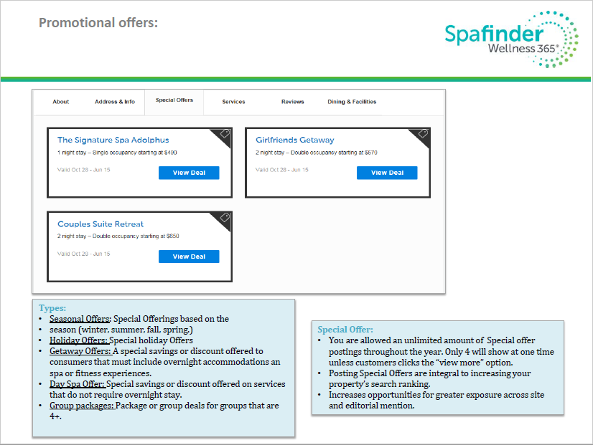
View Deal:
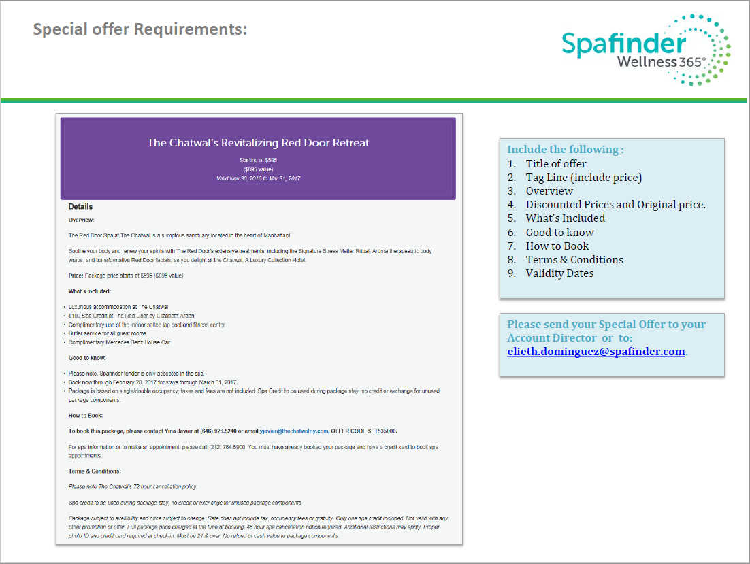
- Once profile is complete, send preview to the partner for approval: example: Lifestyle Tropical Beach Resort & Spa
  - Make any changes requested by the partner
- Once Approval is received
  - Confirm payment has been received with finance
  - Set profile live via admin
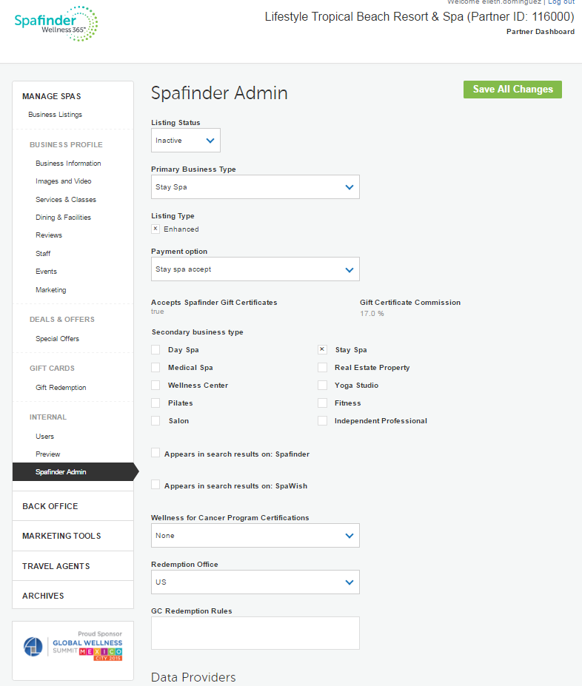
- Update Salesforce TMP Start & End dates.
  - Send out notification to the partner that includes;
    - Login details for the partner portal
    - TMP best practices
    - Partner Portal Guidelines
    - Request to set up a call to walk them through the partner portal and gift card redemption process.
    - Partner & Gift Card FAQ https://www.spafinder.com/pages/partners-faqs/

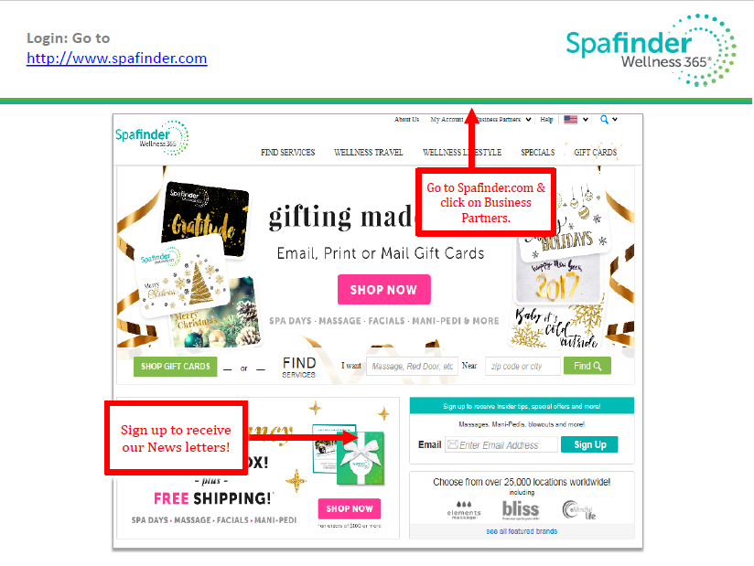

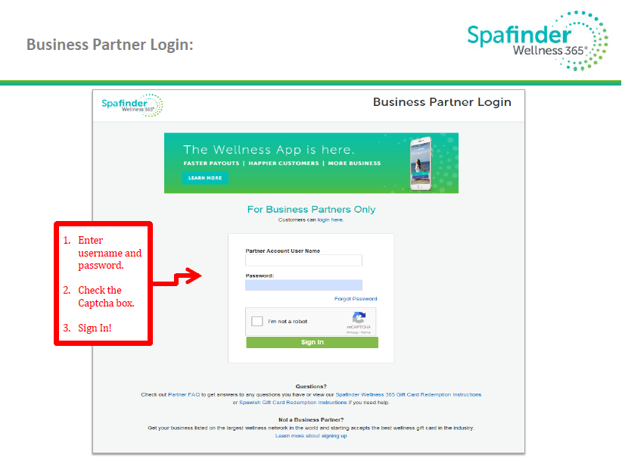
- Spafinder Wellness Redemption History will allow the partner to view gift cards that have been redeemed
  - To redeem denominational gift card / gift certificates the partner must enter both the card number & the value
  - To redeem gift cards that are non-denominational the partner must enter both the card number & pin code

