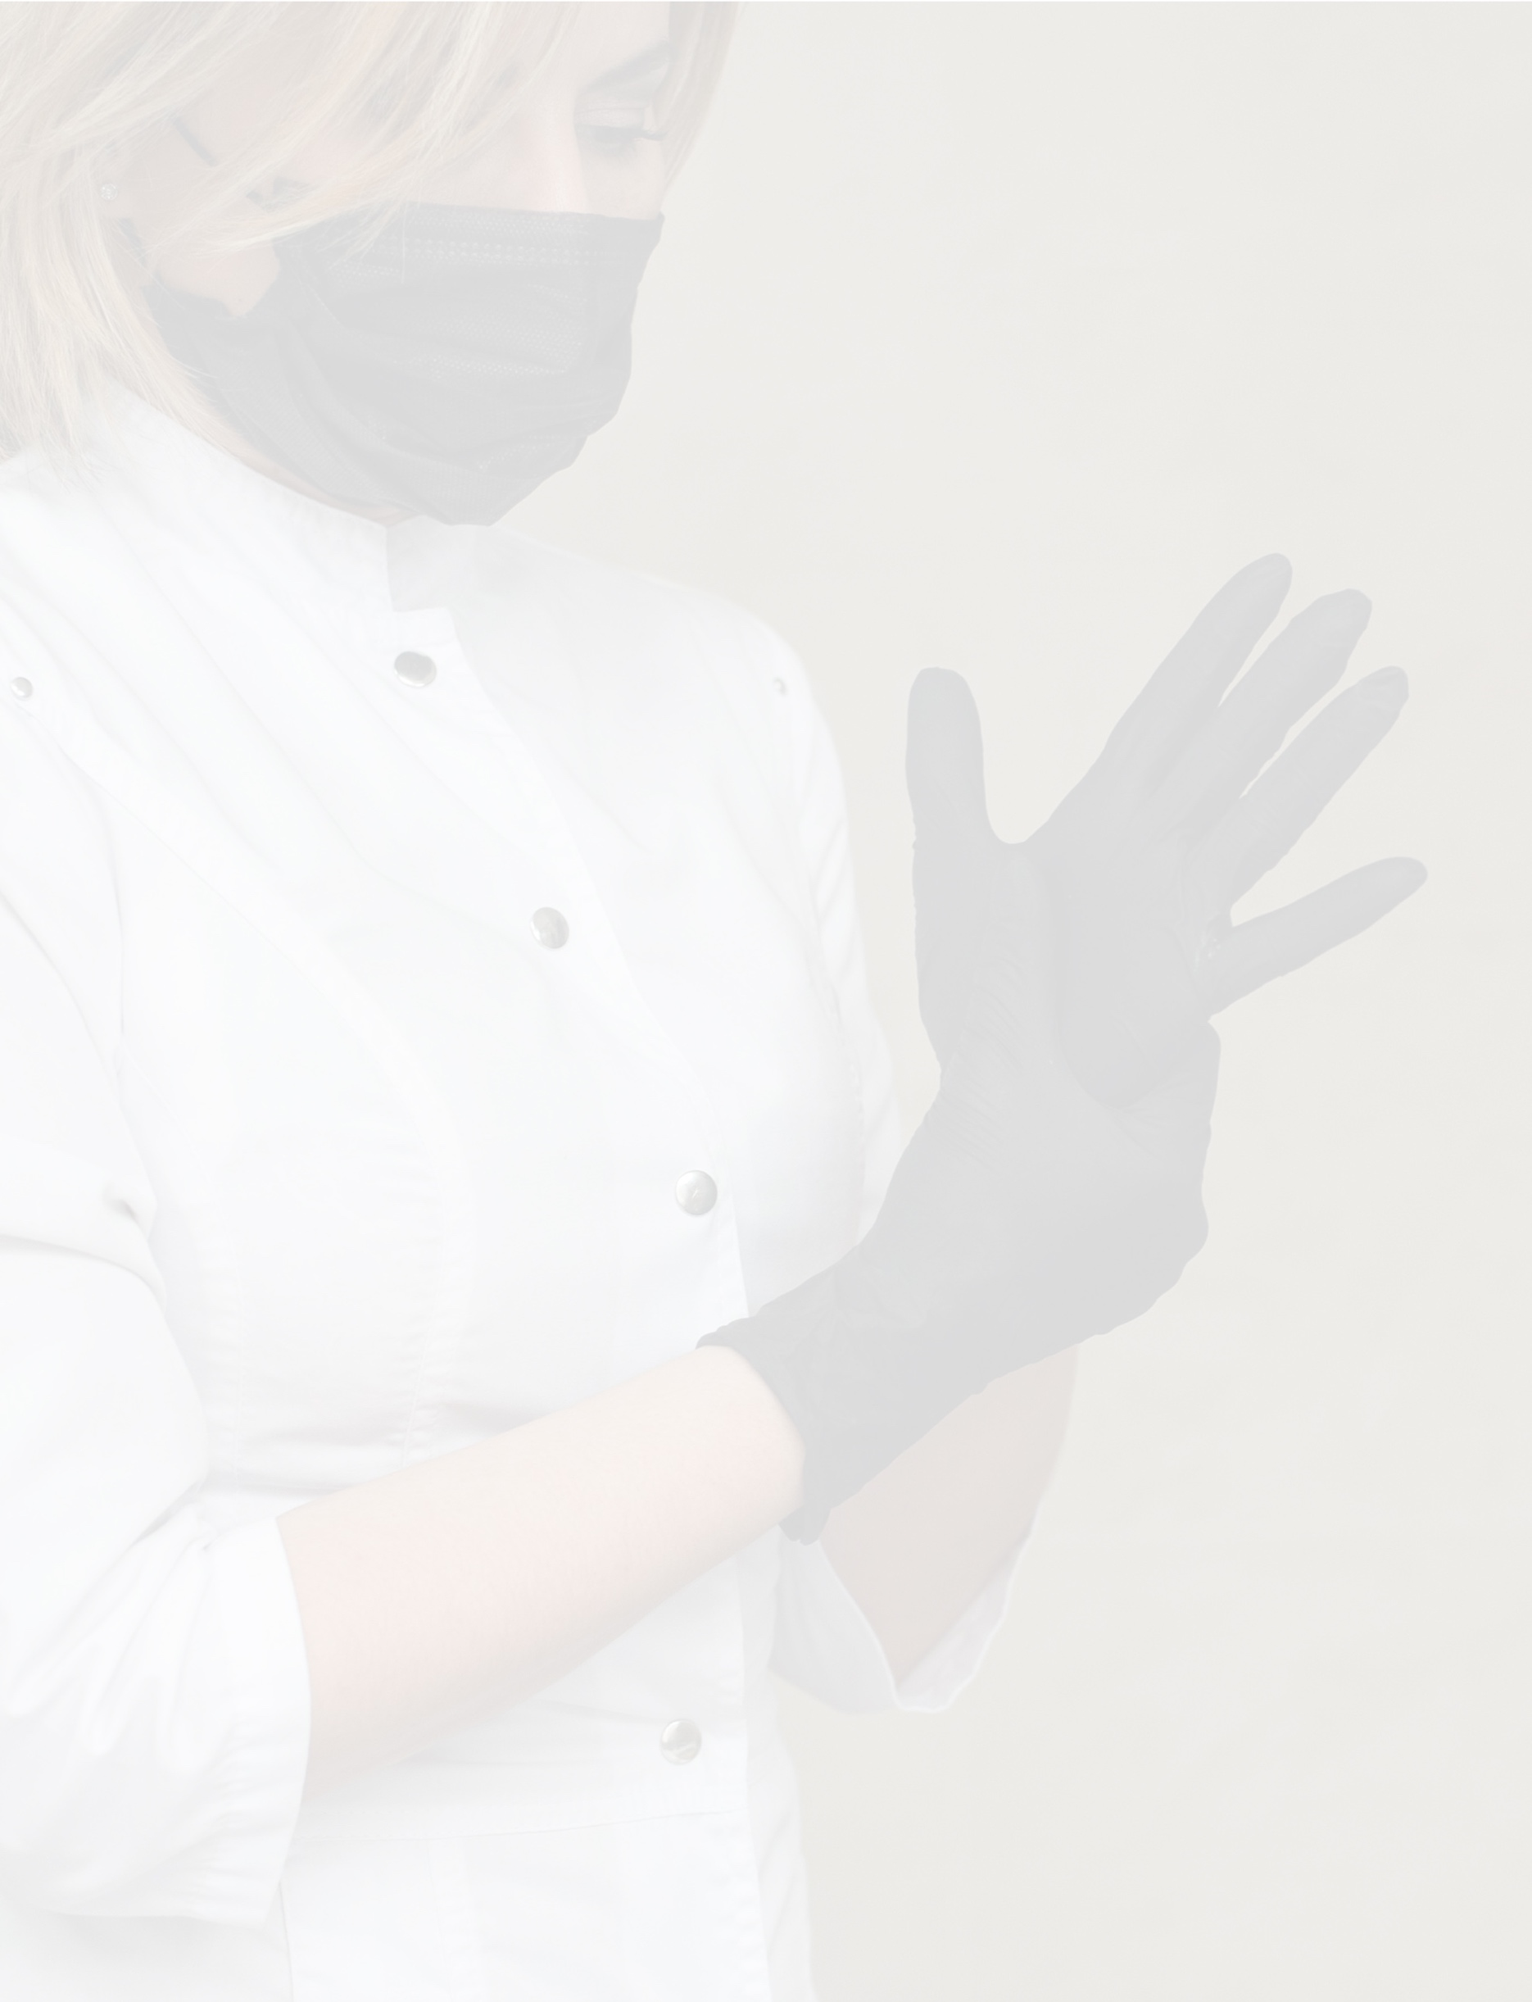

reopening FAQ:
Staff and employees
{INSERT SPA NAME}
[This template provides general guidance for developing a staff-facing FAQ that clarifies spa policies and procedures related to reopening following COVID-19-related closures. The specific questions and answer options provided below are only examples. Add, amend or delete questions in the “Question” column as needed, and insert answers in the corresponding location in the “Answer” column according to your spa’s policies.]

QUESTION | ANSWER
What do I do if I feel unwell or exhibit symptoms of COVID-19 at home? | - Do NOT come to work if you are feeling unwell or exhibit symptoms of COVID-19, including:  - A persistent, dry cough  - Shortness of breath or difficulty breathing  - A fever of 100.4° or higher  - Chills  - Muscle pain  - Sore throat  - New loss of taste or smell
What do I do if I feel unwell or exhibit symptoms of COVID-19 while at work? | - If you are with a guest or performing a treatment:  - Stop treatment IMMEDIATELY  - As much as possible, refrain from touching surfaces or entering new areas of the spa  - Discreetly notify your supervisor while maintaining a distance of at least six feet from other individuals  - [Additional step]  - [Additional step]  - [Additional step]  - [Add/remove steps as needed]
What procedure should I follow if a guest exhibits clear symptoms of  COVID-19? | - [Answers will vary based on spa policy. Enter yours here.]
Will I have to wear a mask or gloves during treatment/service? | - [All staff are expected to wear cloth face coverings during interactions with guests, including during treatments.  Gloves are only required if specifically requested by a guest.]
Will guests be required to wear face masks inside the spa? | - [Answers will vary based on spa policy and government regulations. Enter yours here.]
Is there additional turnover time between treatments? | - Yes. To allow for heightened sanitation procedures, turnover time is now [XX] minutes.
How will additional turnover time affect scheduling and pay? | - [Answers will vary based on spa policy. Enter yours here.]
Will I have new duties or areas of responsibility regarding sanitation? | - [Answers will vary based on spa policy. Enter yours here.]
How will social distancing be practiced/monitored in back-of-house/staff areas? | - [Answers will vary based on spa policy and government regulations. Enter yours here.]
If I don’t feel comfortable performing certain treatments, can I refuse to do so? | - [Answers will vary based on spa policy. Enter yours here.]
What if I am unable to return to work because I am caring for a child or high-risk individual? | - [Answers will vary based on spa policy. Enter yours here.]
What if I am considered high-risk and am uncomfortable returning to work upon reopening? | - [Answers will vary based on spa policy. Enter yours here.]

