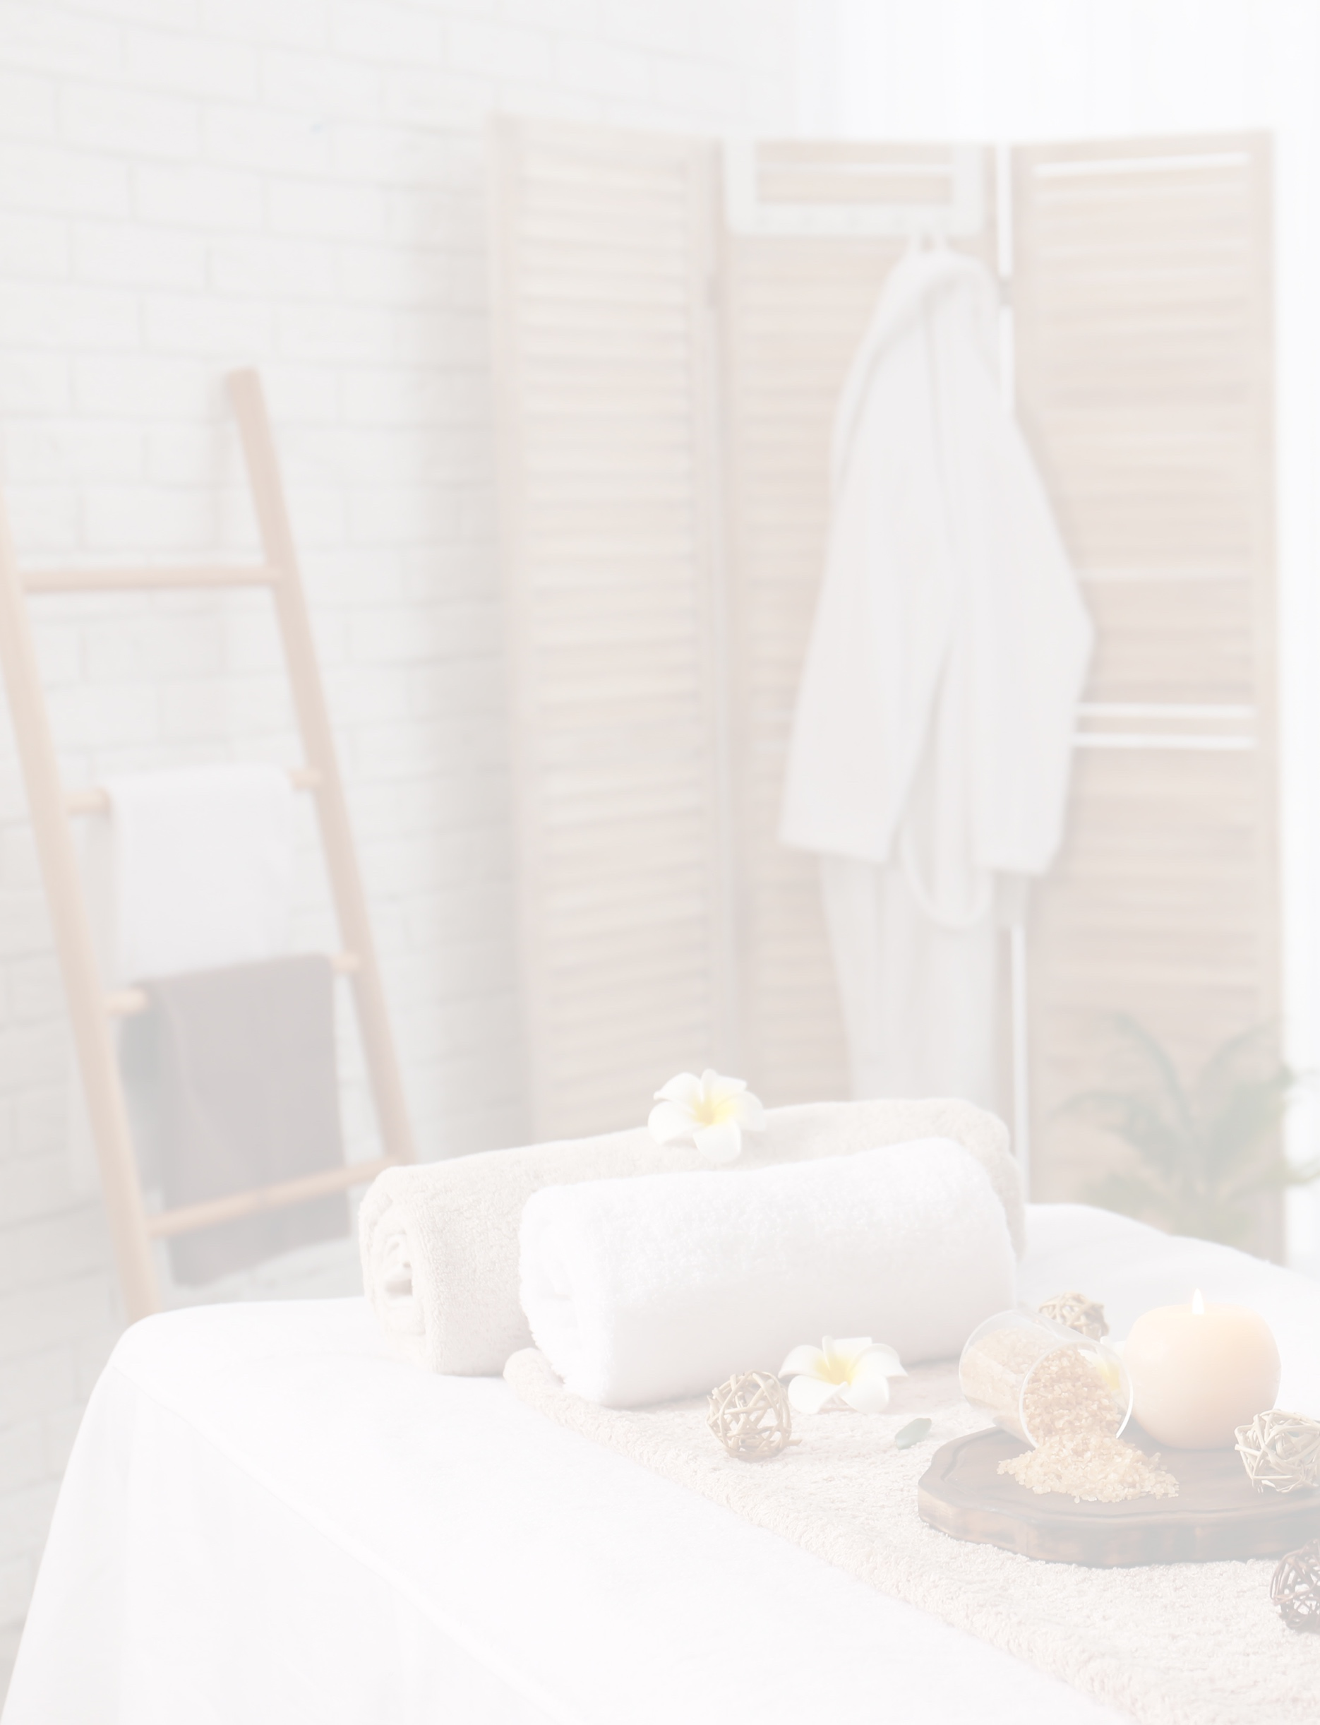
Reopening policies and procedures
TALKING POINTS FOR CUSTOMER CONCERNS
{INSERT SPA NAME}
[This template provides general guidance for developing a set of talking points spa staff may use when responding to guest questions related to reopening following COVID-19-related closures.The specific questions and answer options provided below are only examples.Add, amend or delete questions in the “A guest asks:” column as needed, and insert answers in the corresponding location in the “In your own words, respond with:” column according to your spa’s policies.]
A guest asks: | In your own words, respond with:
Why isn’t the service or treatment I usually get available? | - To ensure that every service or treatment can be performed while following the guidelines established to reduce the spread of COVID-19, we have temporarily simplified our treatment menu.  - If you would like, I can suggest an alternative treatment or service that might suit your needs.
Why are your hours/treatment times different than before? | - [Your spa name’s] revised hours and treatment schedule better allows us to practice heightened levels of hygiene and sanitation while complying with the requirements set forth by [government agency or similar].  - Our new hours of operation are [updated schedule here].
What is the spa doing to keep me safe during a service or treatment? | - [Your spa name] has heightened our already rigorous hygiene and sanitation practices, including:  - [New policy #1]  - [New policy #2, etc.]  - If you would like more information, I can direct you to [website].
Will the arrival and/or check-in process be different? | - Yes. When you arrive at the spa, please follow these steps to assist our staff as they facilitate our new arrival and check-in process:  - [New step #1]  - [New step #2]  - [New step #3, etc.]
If all spa amenities are not available, will I pay a discounted rate for services? | - [Yes. Our current treatment menu pricing reflects the reduced rates.]  OR  - [No. Current pricing on services and treatments allow us to fairly compensate our therapists, service providers and staff. We look forward to once again offering a full slate of amenities as soon as possible.
Will the sauna, steam room and other wet areas be open? | - Yes. Wet areas in [your spa name] will be open with certain restrictions, noted below:  - [Restriction #1]  - [Restriction #2, etc.]  - No. To allow guests to more easily practice social distancing and to ensure [your spa name] is able to maintain the highest levels of sanitation throughout our facility, wet areas are temporarily closed to guests.
Are spa staff being tested for COVID-19 or getting their temperatures checked before returning to work? | - [Answers will vary based on spa policies and government regulations].

Do I have to wear a mask while visiting the spa? | - Out of respect for the health concerns of our staff and other guests and in alignment with the recommendations of [government agency or similar] we ask that you wear a cloth face covering or similar during your visit.  OR  - Although we encourage anyone (including staff) who wishes to wear a face covering to do so, we are not requiring guests to use them at this point.
How will your spa enforce social distancing guidelines? | - [Answers will vary based on spa policies and government regulations.]

